*Independent University Bangladesh (IUB)* **Course ID: CSE316L  
Semester:  Summer 2021  
Section: 04  
  
  
Submitted To:  
Instructor:** **Dr. Mst. Najnin  
  
Submitted By:  
Name: Md. Ashikur Rahman  
ID: 1831110  
  
Lab Report 9**

**Working Date:  24th August 2021  
                                      Submission Date: 25th August 2021**

**RIP Conﬁguration**

**Objective:**

Your task is to configure (RIP) Routing Information Protocol between PC1, PC2, PC3 and PC4

1. Built network according to Figure 1
2. Configure RIP between the routers
3. Ping from each PC to all other PCs
4. Check Routing Table for all the routers

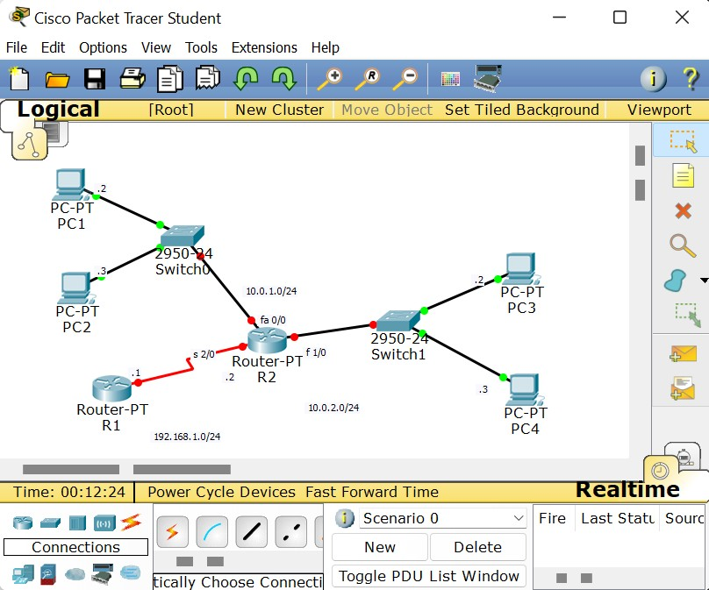

Tools and Materials:

In a real-life Scenario:

Four Workstations with terminal Program (such as putty), one Cisco switches, One Cisco Router, three Straight-through RJ45 cables and two RJ45 cross-over RJ45 cables

For Lab Purpose:

Cisco Packet Tracer Software

Router> enable Router #config t

Enter configuration commands, one per line. End with CNTL/Z. Router(config)#int fa 0/0

Router(config-if) #ip address 10.0.1.1 255.255.255.0 Router(config-if) #no shutdown

Router(config-if) #

%LINK-5-CHANGED: Interface FastEthernet0/0, changed state to up

%LINEPROTO-5-UPDOWN: Line protocol on Interface FastEthernet0/0, changed state to up Router(config-if) #exit

Router(config)#int fa 1/0

Router(config-if) #ip address 10.0.2.1 255.255.255.0 Router(config-if) #no shutdown

Router(config-if) #

%LINK-5-CHANGED: Interface FastEthernet1/0, changed state to up

%LINEPROTO-5-UPDOWN: Line protocol on Interface FastEthernet1/0, changed state to up Router(config-if) #exit

Router(config)#int s 2/0

Router(config-if) #ip address 192.168.1.2 255.255.255.0 Router(config-if) #no shutdown

%LINK-5-CHANGED: Interface Serial2/0, changed state to down Router(config-if) #hostname R2

R2(config)#

Router> enable Router# config t

Enter configuration commands, one per line. End with CNTL/Z. Router(config)#hostname R1

R1(config)#int s 2/0

R1(config-if) #ip address 192.168.1.1 255.255.255.0 R1(config-if) #no shutdown

R1(config-if) #

%LINK-5-CHANGED: Interface Serial2/0, changed state to up R1(config-if) #

%LINEPROTO-5-UPDOWN: Line protocol on Interface Serial2/0, changed state to up R1(config-if) #exit

R1(config)#router rip

R1(config-router) #network 192.168.1.0 R1(config-router) #

R1(config-router) #do show ip route

Codes: C - connected, S - static, I - IGRP, R - RIP, M - mobile, B - BGP D - EIGRP, EX - EIGRP external, O - OSPF, IA - OSPF inter area

N1 - OSPF NSSA external type 1, N2 - OSPF NSSA external type 2 E1 - OSPF external type 1, E2 - OSPF external type 2, E - EGP

i - IS-IS, L1 - IS-IS level-1, L2 - IS-IS level-2, ia - IS-IS inter area

* - candidate default, U - per-user static route, o - ODR P - periodic downloaded static route

Gateway of last resort is not set

R 10.0.0.0/8 [120/1] via 192.168.1.2, 00:00:24, Serial2/0

C 192.168.1.0/24 is directly connected, Serial2/0 R1(config-router) #

R1(config-router) #version 2 R1(config-router) #no auto-summary R1(config-router) #

R1(config-router) #do show ip route

Codes: C - connected, S - static, I - IGRP, R - RIP, M - mobile, B - BGP D - EIGRP, EX - EIGRP external, O - OSPF, IA - OSPF inter area

N1 - OSPF NSSA external type 1, N2 - OSPF NSSA external type 2 E1 - OSPF external type 1, E2 - OSPF external type 2, E - EGP

i - IS-IS, L1 - IS-IS level-1, L2 - IS-IS level-2, ia - IS-IS inter area

* - candidate default, U - per-user static route, o - ODR P - periodic downloaded static route

Gateway of last resort is not set

10.0.0.0/8 is variably subnetted, 3 subnets, 2 masks

R 10.0.0.0/8 is possibly down, routing via 192.168.1.2, Serial2/0 R 10.0.1.0/24 [120/1] via 192.168.1.2, 00:00:12, Serial2/0

R 10.0.2.0/24 [120/1] via 192.168.1.2, 00:00:12, Serial2/0

C 192.168.1.0/24 is directly connected, Serial2/0 R1(config-router) #

 Desktop fuetor Interface



D H C P '2 ta ti c

I P Ad d ress 1D.D. 1. 2

S u bnet M asl< is s . is s . is s . D

D ef°a u I t G a tewva y 1 D. D. 1. 1

D NE *E e roe r* D.D.D. D

I P v 0 C o n fig LJ *ra* tio n

D H C P A u to C o n fig 0 'B ta tic , I P v 0 Ad d *ress* /

Lin k Loc aI Ad d ress FEB D: : 2 D 1 : C9 F F : F EB 9 : B4 D 2 I P v 6 G a teway

I PvO D N 'B 'B *e roe r*



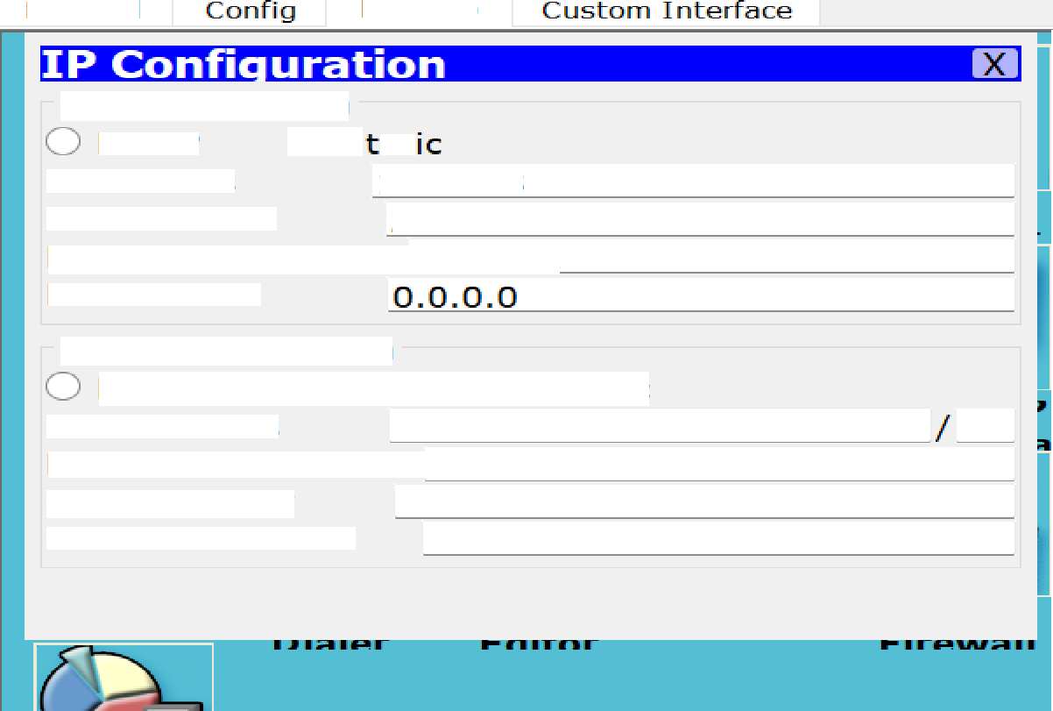

Phys i caI

D eskto p

IP Configuration

DHCP 0 S at

I P Add ress 1D. 0. 1. 3

Subnet M ask Zs 5. Zs s. Zs s. D

Defa uIt Gateway 10.D.1. 1 DNS Server

I Pv6 Config uration

DHCP Auto Config @ Static I Pv6 Address

Li nk Loca I Add ress FEaD: : 2D1 : C 7 FF: FE 17 : 5 6D2

I Pv6 Gateway

IPv6 DNS Server

  



I P C a n Fi g ci ra ti a n

D H C P '2 ta Li c

I P Ad d ress 1O.O. 2.2

E ci b n et M a sl< 2 SS. z s s. z s s. o

D eta i I t G a tevvay 1 O.O. 2. 1

D NE *E• e roe r* o. o. o. o

I P v 6 C a n ii g rJ ma Li a n

D H C P A rJ to C a n ii g '2 ta Li c

I P v0 Ad d *ress /*

LinI< Loc a I Ad d ress I= i= a o: : z oc : a s I=F : FE 6 S : DB GB

I P v6 G a tevvay

I P v 6 D N IN E e are r 



  D e s l<Lo p



D H C P E La ti c

I P Ad d ress 1D.O.Z.3

E rJ b n eL M a s I< 2 ''. 2 s s. 2 s s. O D eFa i IL G a tevvay 1 D. D. 2. 1

D NJE E e roe r O.O.D. O

D H C P A rJ to C a n Fi g E ta Li c

I P v O Ad d ress  LinI< Loc a I Ad d ress F E it O : :2 OA :F 5 F F :F E OF : A B '



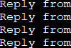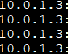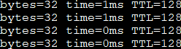

t :

g g . . .3 rate 3s t

Command Prom t